# Cognos 10 FM Installation Guide

## Software Installation:

1. Copy the file bimodel_win32_10.1.1_ml.tar.gz from Y:\DataCenter\DW\External Relations\EADW\CognosFM Software to your local machine.
2. Extract the file to a folder on desktop.
3. Open the folder bimodel_win32_10.1.1_ml.tar and click on win32.
4. Click on the issetup.exe to install the Cognos 10 software.
5. Click to next steps and finish the installation.
6. Go to Start 🡪 Programs 🡪IBM Cognos 10 🡪 IBM Cognos Configuration
7. Change the Gateway URI ip address to: act-qa.ucsd.edu as shown in the screenshot below.

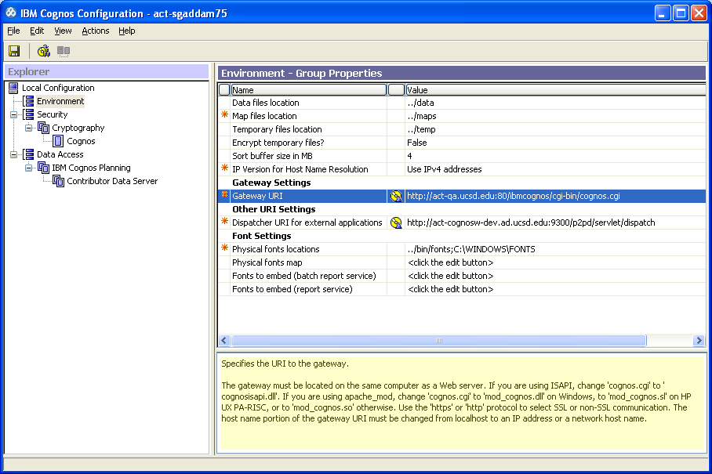

1. Change the Dispatcher URI for external applications to act-cognosw-dev as shown in the screenshot below:

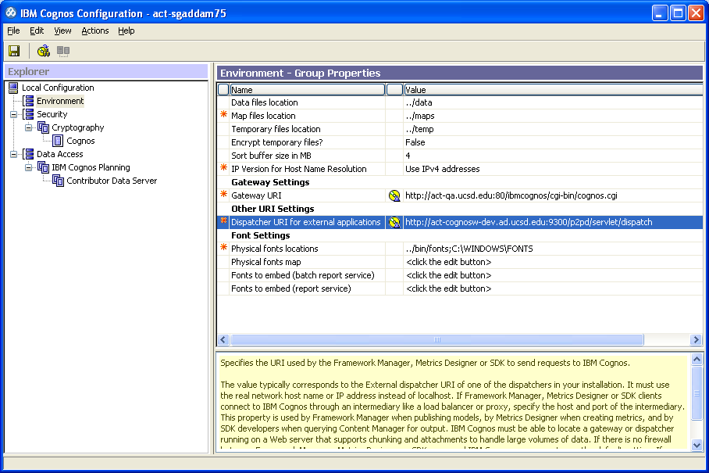

1. Click on Security🡪Cognos and change the password to **security**  as shown in the screenshot below:

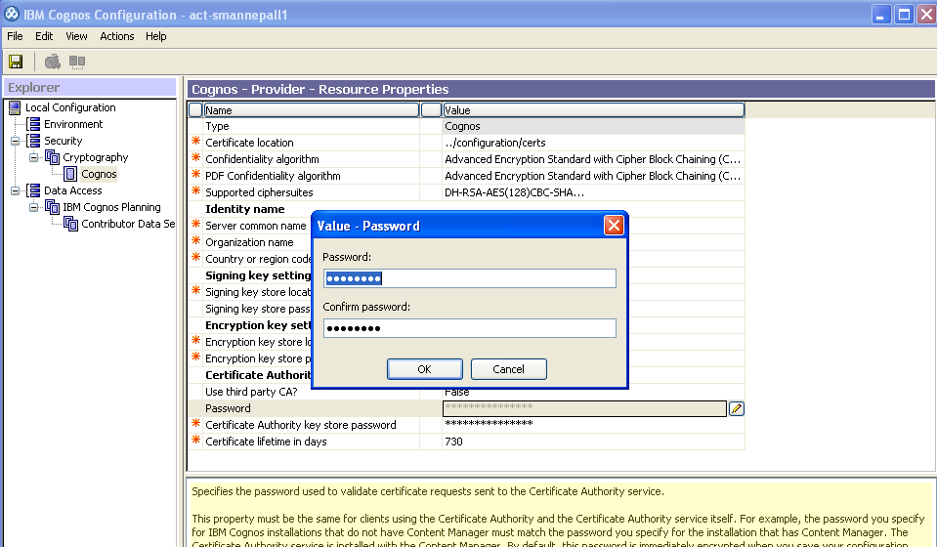

1. Go to File 🡪 Save and exit.

## DB2 Client Setup:

From the command line:

1. cd\
2. cd to the DB2 client installation directory – Example:  cd "Program Files\IBM\SQLLIB\bin"
3. run db2setcp.bat – This should execute and clear the screen.
4. run db2 – This should execute the db2.exe and give you a new command prompt that looks like:   db2 =>
5. Uncatalog all the DBs in db2 catalog: using “list database directory “ get the dbs to uncatalog
   1. uncatalog database DW_DB_F
   2. uncatalog database DW_DB_P
   3. uncatalog database FN_DB
6. Uncatalog all the nodes in db2 catalog: using “list node directory “ get the nodes to uncatalog
   1. uncatalog node DB2ACTP
   2. uncatalog node NDE25B96
   3. uncatalog node NDE25B96
   4. uncatalog node NDEA64E3
7. run the following commands to recatalog:
   1. catalog tcpip node DB2DWP remote dw-p-vip.ucsd.edu server 50000
   2. catalog tcpip node DB2DWQ remote dw-q-vip.ucsd.edu server 50000
   3. catalog tcpip node DB2FNLQ remote fnlnk-q-vip.ucsd.edu server 50000
   4. catalog database FNLNK_DB as FN_DB at node DB2FNLQ
   5. catalog database DW_DB as DW_DB_F at node DB2DWQ
   6. catalog database DW_DB as DW_DB_P at node DB2DWP
8. once these are complete you should be able to run the following two commands and have a catalog that looks similar to the below screen shots
   1. list node directory
   2. list database directory
9. once these are complete you must refresh the db2 catalog cache using the command:
   1. terminate

Note: you should not be updating the “alternate server” parameter, it’s updated automatically by DB2 the first you connect to the database. So, after your first connection to a database, you can run:

“db2 list database directory” to verify those values.

## Node List

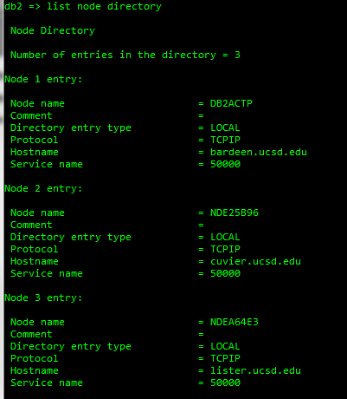

## Database List

